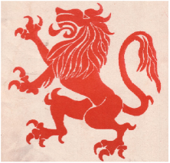

**PHYSICS DEPARTMENT**

**S 5 Test**

**March 2015**

**Paper 2**

**Time 1 hour**

Attempt **ALL** the questions.

1. (a) Using a ray diagram show that the image formed by a plane mirror is as far behind as the mirror as its object is in front of the mirror. (3)

θ

X

Y

O

P

(b)

Two mirrors, X and Y, are inclined to each other at an angle θ. A ray from O strikes X at P as shown. Use the given diagram to show that after the next reflection on Y the net deviation is 2θ.

(4)

(c) Describe an experiment to verify that the angle of reflection is equal to the angle incidence.

(5)

(d) (i) Show that if the incident ray is kept constant but the mirror is rotated, the reflected ray is rotated by twice the angle. (4)

(ii) Describe one application of the principle in (d)(i) above (4)

2. (a) (i) State the first law of electrostatics. (1)

(ii) An electroscope is charged negatively. Then a conductor is brought near its cap. State and explain what is observed. (4)

(b) State the advantages of charging by induction over that by contact. (2)

(c) (i) Explain the mechanism of point action in conductors (3)

(ii) With the aid of a diagram describe how a Van de Graaf generator works (7)

(iii) What factors determine the maximum p.d that can be developed by this generator? (3)